**Add User by Console Access (ID & Password)**

* Login to your IAM console
* In the left navigation panel choose **Users** in **Access Management** section.
* Click on **Add Users**

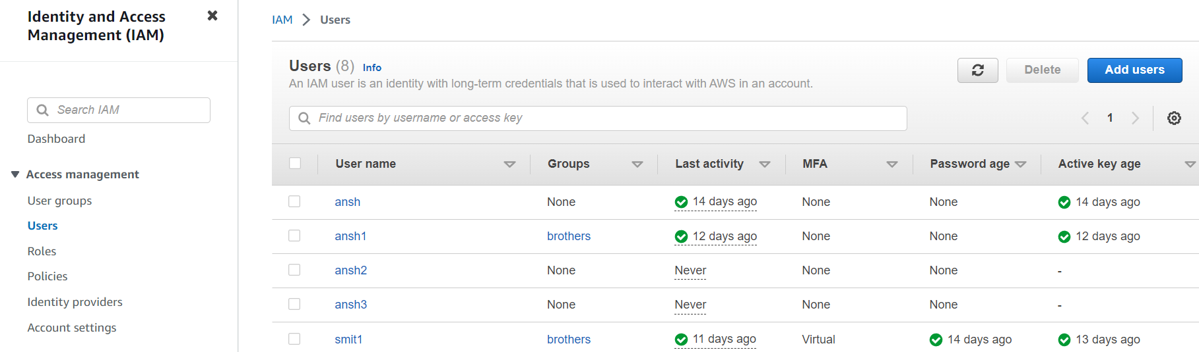

**Step 1 :- Specify user details**

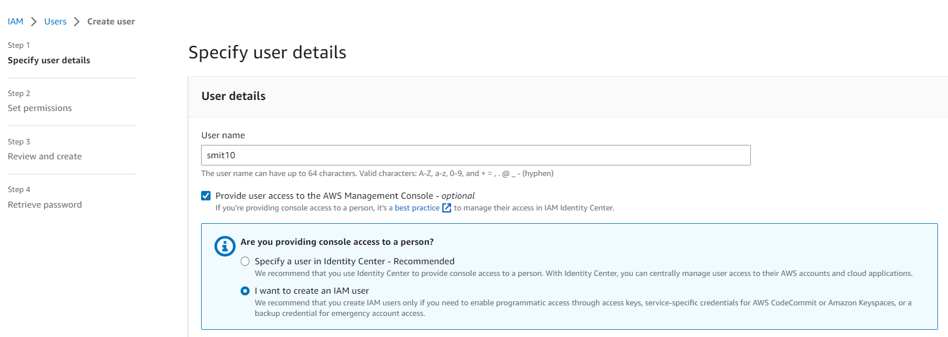

* Enter **User name**
* Select boxof **Provide user access to the AWS Management Console**
* Select **I want to create an IAM user**
* In **Console Password** select **Custom password** and enter suitable password
* **Deselect** Users must create a new password at next sign-in(recommended).

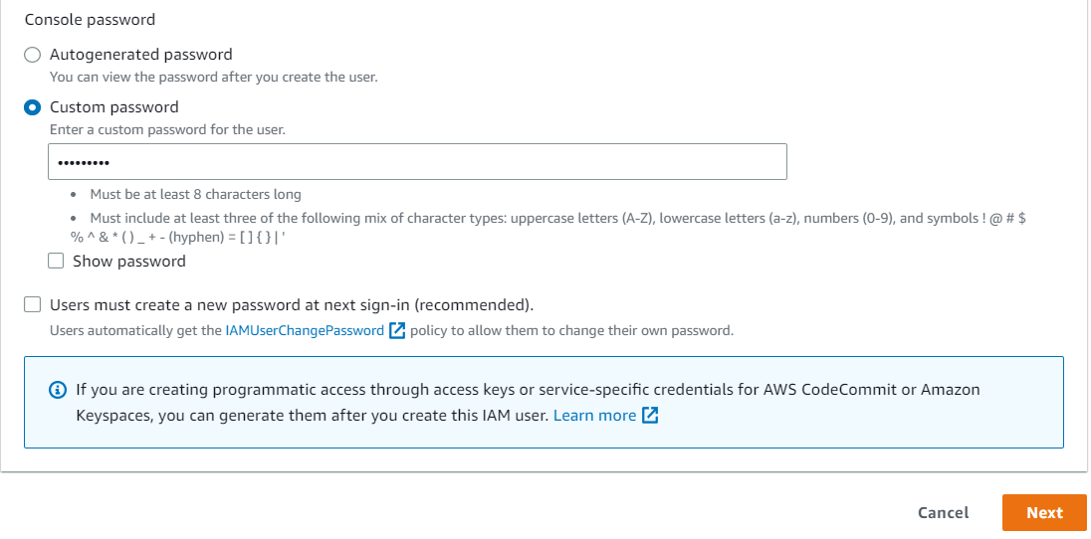

* Click on **Next**

**Step 2 :- Set Permissions**

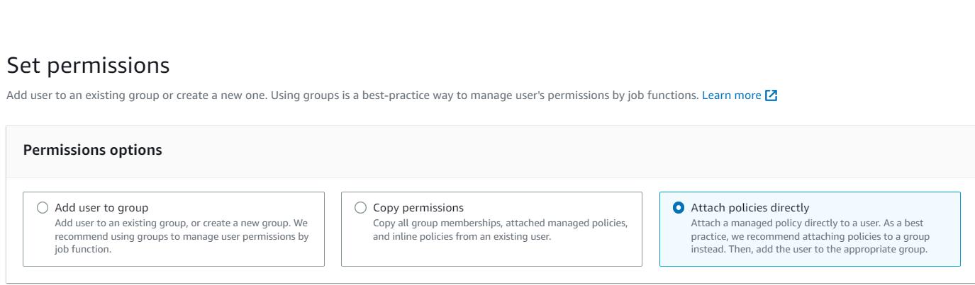

* In Permission Options select **Attach policies directly**

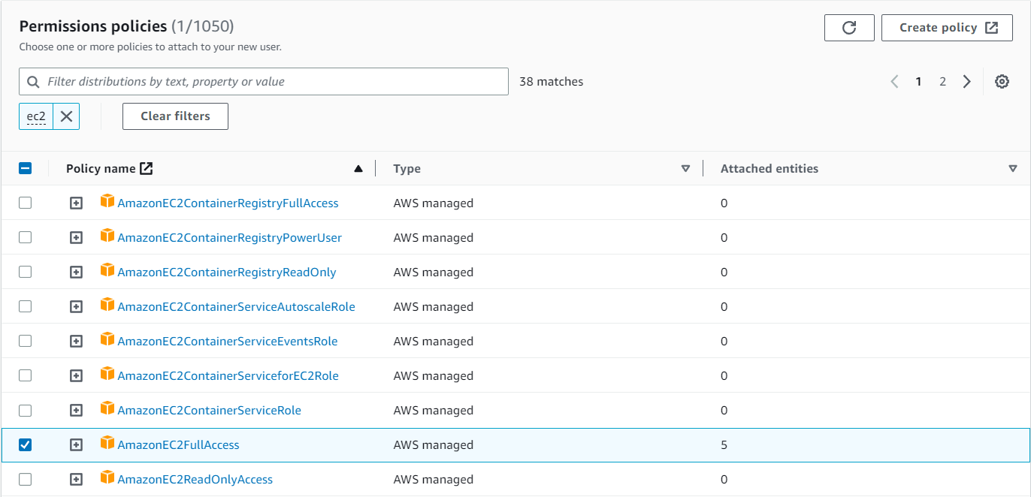

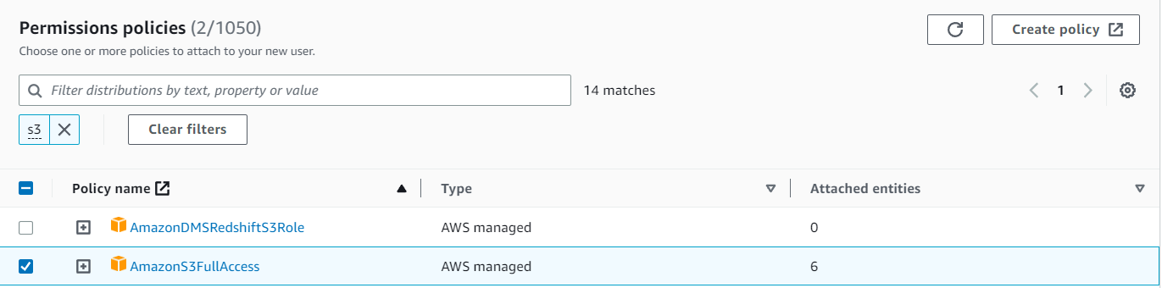

* In Permissions policies select **AmazonEC2FullAccess** and **Amazon S3FullAccess**
* Click on **Next**

**Step 3 :- Review and create**

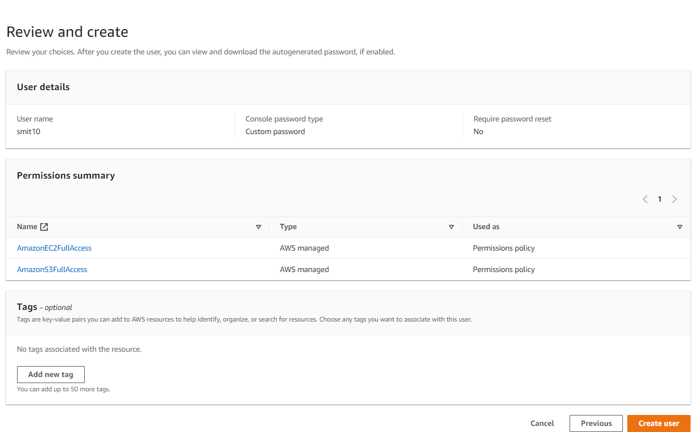

* We can add **Tags** to AWS resources to help identify, organize, or search for resources.

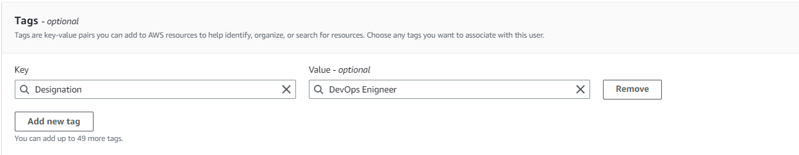

* Click on **Create user**

**Step 4 :- Retrieve password**

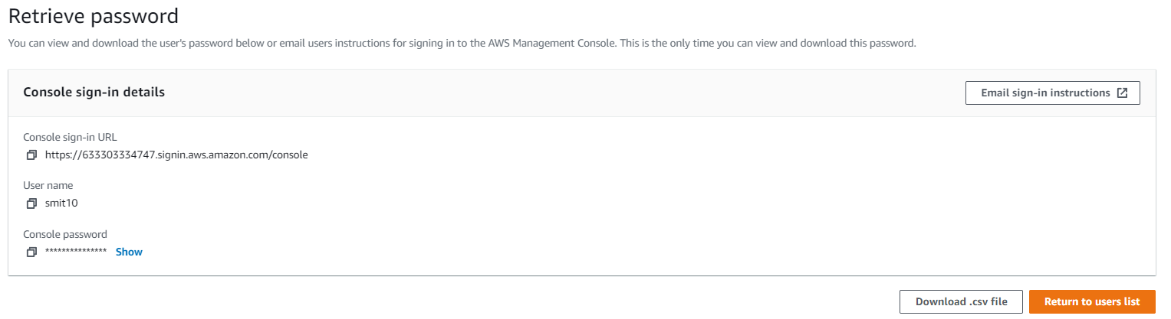

* We can **Download .csv file** or **copy Console password directly**.
* So now user **“smit10”** has been created in users list by using Console Access.